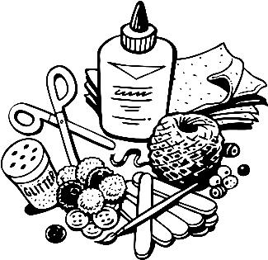
Possibilities Closet

Below is a list of items we could use in the art departments at MHS. If you have any of these items at home and would like to donate for use by students, your support would be greatly appreciated.
If there is a remote possibility we can do something with it, then send it…. We are VERY creative. If we can’t use it, we’ll either find someone who can or we will toss it lovingly.

Special items:
Small (2 ft?) aluminum ladder
Masterpiece Game – complete (Only need 1 more copy)
Lg oatmeal or similar containers (we have 20 and need at least 60)
Asst Balls
Happy Meal Toys
Glow in the dark items.
National Geographic magazines
Sandstone or other soft stone

General items:
Beads
Old jewelry
Buttons
Yarn
Nylons
Crochet thread
Embroidery thread
Plain wire need to be able to bend
Colored wire – electrical scraps work
Jewelry wire
Paper grocery sacks
Stencils
Craft gems
Scrapbooking odds & ends
Small scrap wood pieces and shapes
Small containers with lids if possible
Envelopes
Paper plates
aluminum foil
toothpicks
craft/popsicle sticks
wood shapes
ink pad
SD Cards – sm (older) & lg memory sizes
rubber stamps
glitter
pompoms
feathers
googly eyes
white glue (Aleene's Tacky Glue or Sobo)
Mod Podge
fabric glue
wood glue
scissors
paintbrushes
wax paper
clear contact paper
freezer paper
candle wick string
metal washers
small fabric bows
needle nose pliers
wire cutters
tin snips
hammers
safety glasses
play dough tools

ITEMS MAY BE DROPPED OFF AT THE SCHOOL OFFICE …….Thank you!

